The headteacher at your school has agreed that we can come into your child’s school

Example scenarios: Developing evaluation questions:

Evaluation questions and combining data
These two items appear on the outputs section of a logic model: ‘15 group courses run per year’ and ‘100 parents completing a group course’. These would have the questions: ‘How many group courses ran per year?’ and ‘How many parents completed (attended at least 5 of 7 sessions) a group course?’.
The service manual states that a group should have between 7-12 participants.
The service design group feels it is important to understand whether groups are well attended and whether times and locations change this. To address this you need to ask both:
How many courses had at least 7 participants complete?
Did the courses that had at least 7 participants differ in time and/or location to those that did not?
To answer these questions, you will need not just the number of courses and the number of completing parents, but also the number of parents completing by course and the time and location of each course.
All these data points need to be available in a way that can be linked together. So thinking carefully through the things that are important and the questions that need answering will feed into the production of your process flow. Ensure that you work with the data lead/team in designing a system that can record these things in linked ways.

Worked example of a before and after evaluation question
The (2021) logic model for Incredible Years states:
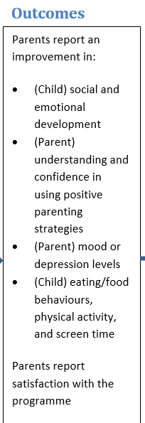
The service design group feel that these outcomes are particularly important to them.
Looking at the Levels of Evaluation document the group agrees that this would be best suited to a before and after evaluation.
The service has an academic partner, who is involved in this process. They suggest that there are verified measures such as the ASQ for social and emotional development and the PHQ-9 that could potentially be built into surveying with participating parents and used to assess these two outcomes.
The group have a few attempts at formulating a question based around the information and decisions they have made so far and together they make suggestions to improve the questions until they are happy (see below).
The group feels that completing one of the possible measures would not be overly onerous for families, and that staff could input the results into their existing family records system. Because the proposal is for a before and after evaluation no comparison group would be required.

What is the improvement in social and emotional development of toddlers taking part in Incredible Years?
To improve on this: we don’t know that it will be an improvement, so we want to explore a ‘change’. It is not actually the toddlers that are the participants, it is the parents.

What change is seen in the social and emotional development of the children of participating parents?
This is getting better – but it is not precise enough, we need to know how we are measuring things.

What change is seen in the ASQ:SE-2 parent reports of parents who participate in Incredible Years?
Getting even closer, but we could be more precise.

What is the change seen between pre-course and discharge in parents’ ASQ:SE-2 reports for parents who attended 8 or more of 13 sessions of Incredible Years?
This is reasonably concise, it is highly specific, we have a way of measuring development (ASQ scores), and it directly relates to the outcome ‘[parents report an improvement in child social and emotional development].
You can see what an answer to this question looked like on page 9 of Incredible Years – Toddler, End of Contract Report, October 2021

The process would be the same or similar for the parental mood or depression levels outcome.

